**THE GUINCHO BEACH**

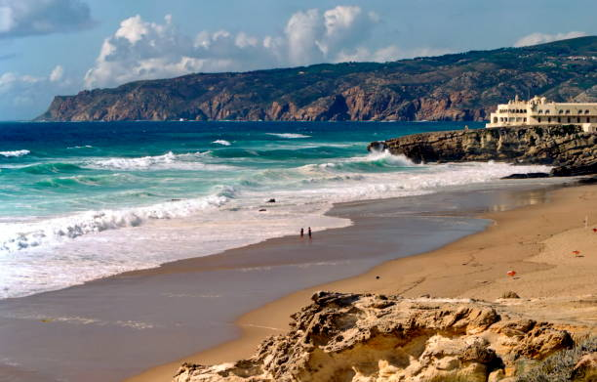Guincho beach is a must-see destination for tourists visiting the Portugal. Located just a short drive from the picturesque town of Cascais, Guincho beach offers a unique blend of natural beauty and adventure. The beach is renowned for its long stretches of white sand, crystal-clear waters, and incredible sunsets.